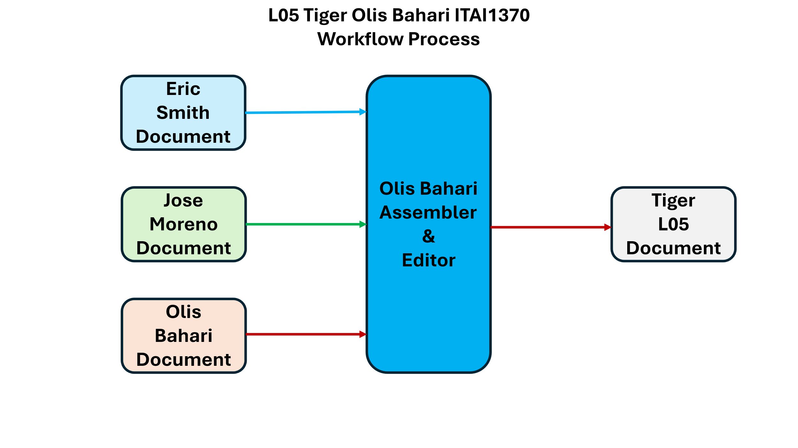

Note:
Blue color is used for Eric Smith work.
Green color is used for Jose Moreno work.
Brown color is used for Olis Bahari work.
L05 ChatGPT, why do I like it so much?
I am a paid customer of OpenAI ChatGPT, Google Gemini, and Aptronics Cloud. These tools are my mentors, teachers, and guides, but I do not trust them; I use my own critical thinking to compare their answers with mine.

ChatGPT has helped me a lot with troubleshooting cars, appliances, and software problems on my laptops. I do not need to call technical support for these issues.

I used ChatGPT as a more AI-based system so I can learn the way I want, whenever I want; it monitors my progress, quizzes me, and tells me when I know the basics of the subject. ChatGPT knows me better, technically, and shows where I am weak or strong. We cannot get that from a classical school.

We must use an AI-based tool from 1st grade to 12th grade in all schools around the world. Texas Alpha High School is at the forefront of innovation and is doing well with the latest AI-based system, but the tuition is $40,000. Students use OpenAI tools for only 2 hours, and the rest of the time is spent learning social, business, and team skills.

